Shorelines Article, February 2017
Introducing your new puppy to your resident dog
You did it! You took the plunge and dove into the world of puppy-dom! Congratulations – You now have a lifelong pal. Let’s get started on the right foot with this little baby – They grow up fast, and if you know Portuguese Water Dogs at all, you’ll know that through that cuteness is a brilliant being that is just waiting to take over your home! Mua-ha-ha!
Since you just got a PWD puppy, there is a good chance you already have a PWD at home (they are like potato chips, right? Once you fall in love with the breed, it’s hard to have just one!). You want to work to set up a great introduction for your resident dog/s and your new puppy. Starting your introduction outdoors is always best. Open air, lots of area to move away if needed. If your resident dog is well-socialized and enjoys the company of other dogs, there should be no need for concern – However, all puppies may react different, so still be aware of their body language. Most puppies when they greet an adult dog will do one of a few things:
- Act like they are not worthy and grovel in front of the dog. Curling themselves into a little ball and crawling around in low circles (please don’t kill me, I mean you no harm!). But watch out, these PWDs are smart little critters. What they’re really doing is testing the waters to see how the adult dog will react to them! OH yes, they’re smart!
- You may have a bold little puppy that runs straight up to your resident adult dog and immediately starts to jump on them, or even hump them! Don’t worry, this is a very common and natural behavior. You didn’t get a dud. However – You don’t want your adult dog to be thinking “gimme a break, what have they brought into my world”! Adult dogs will correct puppies if they feel as though the puppy is being rude, and most of them are actually very appropriate and good at it. But, you don’t really want your dog to get to the point of feeling as though they need to. This is the time to intervene. Gently take your puppy and guide them off of your grown dog. Show them a toy or otherwise redirect them to something that is appropriate to do. Remember, this is their first meeting/greeting and it’s your job to help it go without incident.
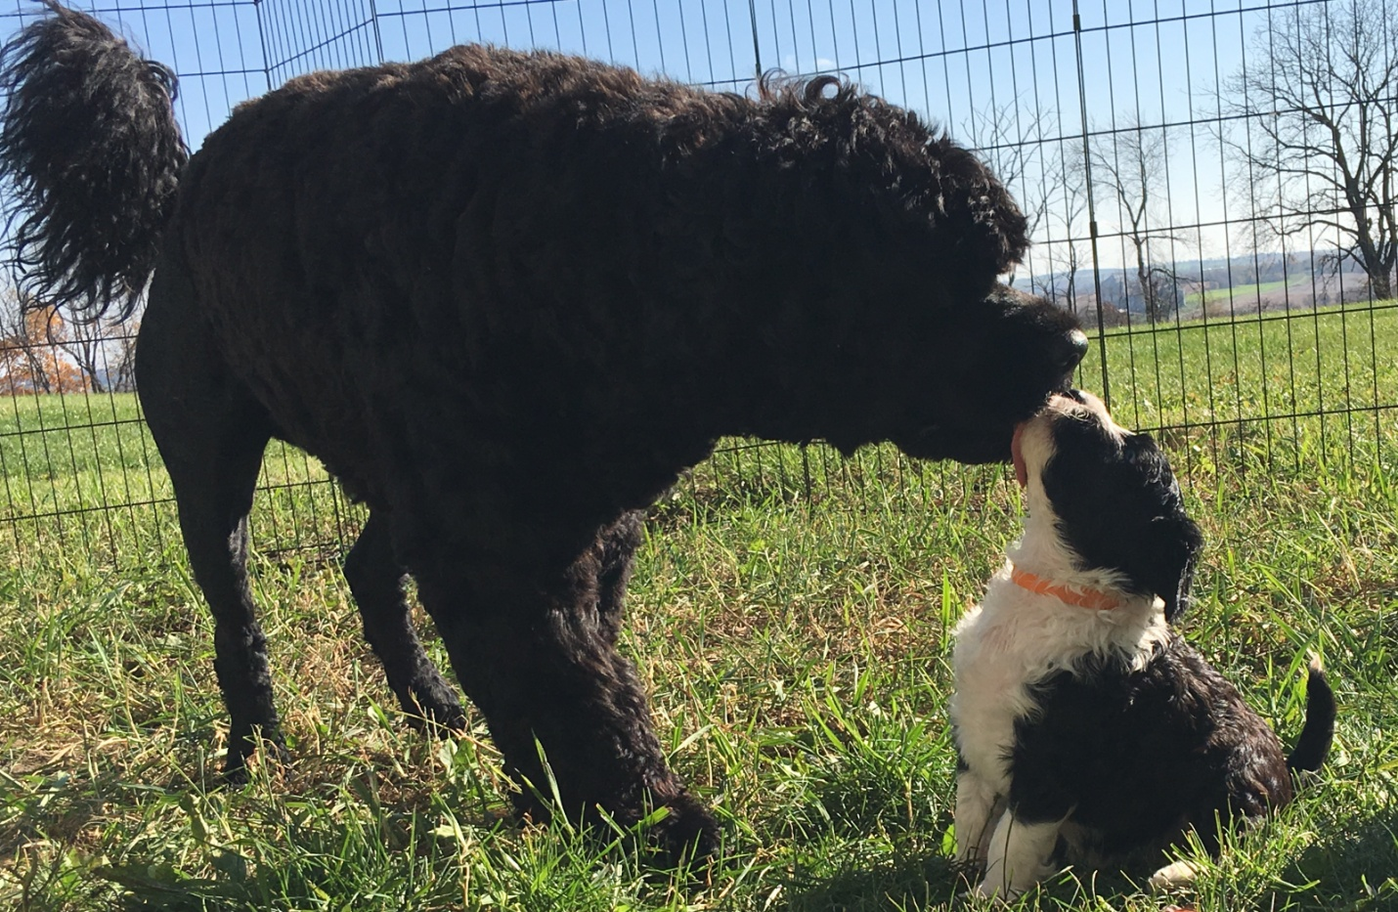
Six-week old Puppy, Morgan, getting licked by 1.5 year old Axl - Axl obviously didn’t read this article!

- Sometimes puppies will lick the muzzle of an adult dog. While this is endearing, because we know that it’s an appeasement behavior, sometimes that little adorable puppy can be “obsessively” licking the grown-up. The adult dog will be turning their head from side-to-side, and sometimes even trying to walk away from the little licking machine. If you notice this, again, time to intervene. If you can help prevent your adult dog from feeling like he/she needs to correct, great. Everything can stay calm and the puppy will still learn good impulse control from the fact that he didn’t get what he wanted (and what he wanted in that situation is some type of reaction from the adult dog). Yes, muzzle licking is a way of puppies getting attention from adult dogs in a way that they know how. But, when you look at it and realize that your cute puppy, that can do no wrong. is actually licking the adult dog to purposely annoy it – Then intervene!
What this picture doesn’t show is how Tallulah kept nudging Axl until he gave up and let her have the whole bed…
You may find that your adult dog still corrects your puppy, and most PWDs are very good at doing this. Your puppy will have learned a lot from it’s dam and it’s breeder, so you can take the fact that they have started down their road of good socialization and continue with it. If you see your adult dog correct your puppy (and it’s appropriate – a quick mouth over the puppy’s muzzle, or sometimes they will pin a puppy down, or sometimes they may give it a good loud bark in the face), it should only last for a split second and then be done. However, your puppy will literally act like it’s being murdered! It will run away screaming and crying. The best thing to do is to totally ignore BOTH dogs. If the correction was warranted and appropriate, there should not be blood or scratches, and both dogs should get over it within a minute. Quick. Done. Puppy learned an important lesson. Don’t annoy older dog.
A great way to have two dogs enjoy each other’s company is to take a walk. Since your puppy is little, “forced walks” are not recommended quite yet, but a couple back-and-forths up and down the driveway can also do the trick! Movement helps to reduce stress. Have both dogs on leashes (two handlers for two dogs) and walk parallel to each other, up and down the driveway. Once you notice that they are both cool with each other, then let them off their leashes in a safe, fenced-in yard. After a while, if you see that they are becoming pals (or, at least the older dog is tolerating the puppy!), you can probably figure it’s okay to bring them into the house.
Some adult dogs will start to engage and play with the puppy right away. This is always fun because, of course, you want them to be friends. But, some adult dogs don’t want to have a thing to do with young puppies. They are of no use to them! Maybe when the puppy is around 4-6 months, the adult dog will figure that it’s actually staying, and it’s old enough to play with (just like husbands that don’t really know what to do with an infant, but once the baby can interact with adult humans, the husbands can have fun with them!). Every dog is different.
I know your puppy is brand new and you want to give it oodles of attention, but – Remember, your resident dog comes first! I would bring puppy into the house – on leash – and walk him in the main room that you’ll be in for the next few hours. Maybe play for a few minutes, but then I’d put him in his crate. Your adult dog needs to feel like he/she can still relax without a puppy annoying him whilst he’s trying to nap on the couch. Plus, frequent crate breaks are so very important for young puppies! It not only helps to teach them great impulse control, but it helps them to take a little break.
Many times I’ll have puppy owners tell me that they are at their wits end because the puppy keeps biting at them, or grabbing things it shouldn’t, etc. I find that they are only crating the puppy at night, or when they leave. These young babies can easily get over tired! Just like a kid, when they are overtired they tend to get out of their brains! I am quick to give a puppy a crate-rest, probably every 45 minutes or so. The time in the crate doesn’t need to be long – Two minutes? Three minutes? Just enough time to help them learn to calm themselves down. Once they do, you can let them out of their crate. But, you may find that many times during a crate break, your puppy will actually fall asleep. They are babies! This gives them the naps they need and the impulse control practice that is invaluable as they get older.
We get these little bundles home and want to take them everywhere and have them see everyone we know! Take the first week-or-so to just relax with your puppy. Let him get to know you and your other dog. The energy of your house, the routine of your family. Then slowly start to introduce him to friends and slowly start to take him places. You have his whole life ahead of him, so take these first couple weeks slowly and let him acclimate to his new life.
​
--Giene
Giene Keyes, Owner and Founder
★ Dog Face, LLC ★ and
★ Shooting Star Portuguese Water Dogs ★

